 | Physical Education: 7th Grade
 | Social Responsibility (Participation): Assessed Per Unit
Score 4.0  Advanced  A+ | In addition to a score 3.0 performance, a student who scores advanced will demonstrate the following:  - Assumes a coaching role by helping classmates, who need additional assistance, with tasks and assignments  - Assumes a leadership role when necessary and does so in a respectful manner  - Demonstrates appropriate risk-taking in order to see personal growth  - Consistently volunteers to demonstrate or speak in class activities and discussions
 | Score 3.5 | In addition to a score 3.0 performance:  - Demonstrates partial success with score 4.0 requirements
Score 3.0  Proficient  A- | A student who scores proficient will demonstrate the following:  - Shows up every day to class, on time, and prepared to learn (includes homework, binder, & suit cuts)  - Actively participates, with the intention to improve, in all class activities and discussions.  - Positive, patient, and persistent when challenges are presented to them.  - Accepting of peers of all ability levels and encourages them to succeed.  - Respectful towards teacher and peers.  - Maintains a safe physical and emotional classroom environment.
 | Score 2.5 | B-
Score 2.0  Basic  C- | A student who scores basic will occasionally fail to meet all 3.0 requirements:
 | Score 1.5 | D
Score 1.0  Below Basic  D- | A student who scores below basic consistently fails to demonstrate 3.0 requirements.
F  ½ Credit | Score  .5 | - Does not maintain a safe class environment (physically or emotionally)  - Receives a behavioral referral  - Refuses to participate in class activities  - Has multiple unexcused tardies and/or absences throughout the unit

List 5 benefits of encouraging teammates in physical activity?

1._______________________________________________________________________________________________

2._______________________________________________________________________________________________

3._______________________________________________________________________________________________

4._______________________________________________________________________________________________

5._______________________________________________________________________________________________

Leadership Responsibilities: Knowing when to assume a leadership role is imperative for group success. Too many leaders can cause conflict and tension between group members and a lack of leadership can cause a group to be unproductive and off task. A quality leader generally possesses the following characteristics:
- Keeps the group focused on the task at hand
- Is assertive and proactive when an issue or obstacle arises
- Values their teammates opinions and makes them feel like their voice is being heard by the group
- Delegates responsibilities so they don’t have to do it all by themselves
- Understands and utilizes teammates strengths and weaknesses
- Maintains a safe environment and encourages teammates
- Provides productive feedback to their individual teammate and the group
- Knows when to make the final decision

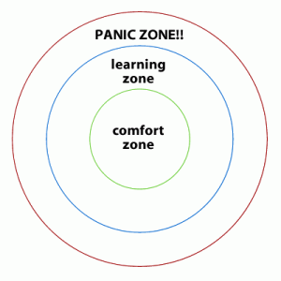
Appropriate Risks in Physical Education: Physical Education is an environment where you will be challenged on a daily basis to step out of your comfort zone in order to see personal growth.

