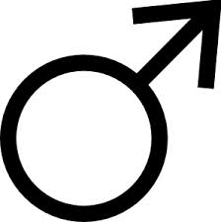
Name ________________________________
Period __________Date __________________

Fall Due Date ________________
Spring Due Date ______________

Measurement Chart for Boys

Measurement | Fall | Spring | Notes
Resting Heart Rate |  |  | Directions:
Height |  |  | -Lay tape on skin, do not squeeze tap
Weight |  |  | -Measure all muscles in a flexed position
Right Bicep |  |  | -Measure in inches
Left Bicep |  |  | -Measure to the closest ¼ inch
Chest |  |  | Measure partner, not yourself
Waist |  |  | Shoes are off during (height, weight, R & L foot)
Hips |  |  | Waist measurement:  Boy: Above belly button
Right Thigh |  |  | Girls: At natural curve
Left Thigh |  |  | Hip measurement at largest part of gluteus maximus
Right Calf

Left Calf

Right Foot

Left Foot

Fall Parent Signature ________________________
Spring Parent Signature_______________________
Name ________________________________
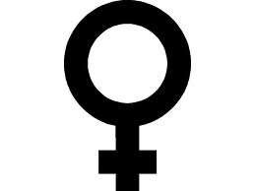
Period __________Date __________________

Fall Due Date ________________
Spring Due Date ______________

Measurement Chart for Girls

Measurement | Fall | Spring | Notes
Resting Heart Rate |  |  | Directions:
Height |  |  | -Lay tape on skin, do not squeeze tap
Weight |  |  | -Measure all muscles in a flexed position
Right Bicep |  |  | -Measure in inches
Left Bicep |  |  | -Measure to the closest ¼ inch
Bustline |  |  | Measure partner, not yourself
Waistline |  |  | Shoes are off during (height, weight, R & L foot)
Hips |  |  | Waist measurement:  Boy: Above belly button
Right Thigh |  |  | Girls: At natural curve
Left Thigh |  |  | Hip measurement at largest part of gluteus maximus
Right Calf

Left Calf

Right Foot

Left Foot

Fall Parent Signature ________________________
Spring Parent Signature_______________________

