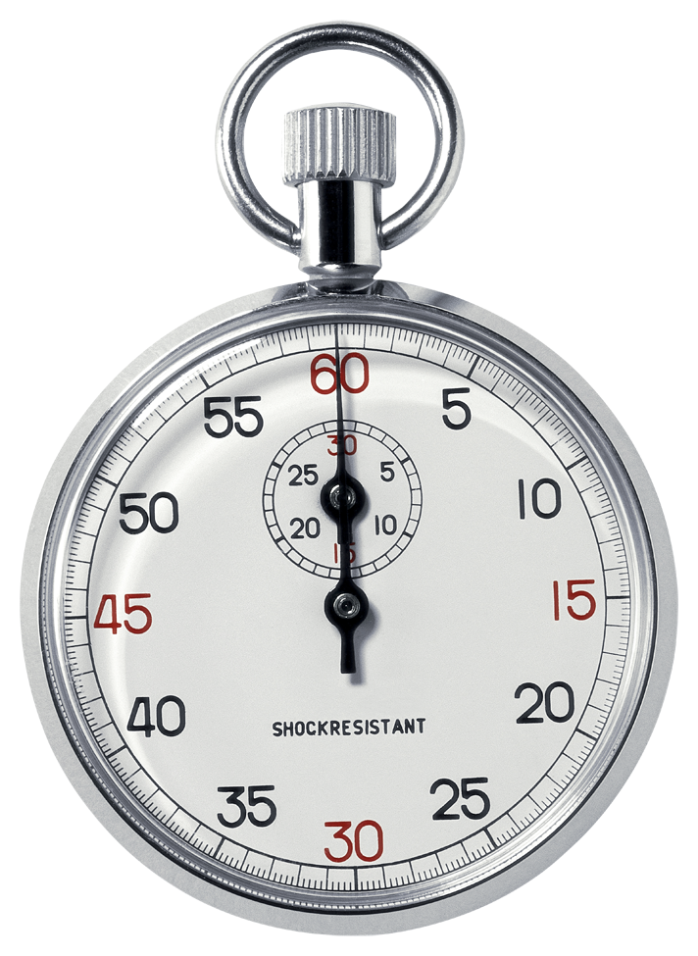
1 MILE MAKE-UP
Name_________________________________________
Period______________________
Date______________________

1. Complete a mile on a school track, with a parent.
2. Parent records split times (How much time has passed after each lap)
3. Parent signs this mile make-up sheet and student returns it to their physical education teacher.

LAP 1 _________________________________

LAP 2 _________________________________

LAP 3 _________________________________

LAP 4 _________________________________ MILE TIME __________________________

Circle the reason for the mile make-up. Medical Absence

Parent Signature _______________________________________________________________
------------------------------------------------------------------------------------------------------------
½ MILE MAKE-UP
Name_________________________________________
Period______________________
Date______________________

1. Complete a ½ mile on a school track, with a parent.
2. Parent records split times (How much time has passed after each lap)
3. Parent signs this ½ mile make-up sheet and student returns it to their physical education teacher.

LAP 1 _________________________________

LAP 2 _________________________________ ½ MILE TIME _______________________

Circle the reason for the mile make-up. Medical Absence

Parent Signature _______________________________________________________________

TIMED RUN MAKE-UP
Name_________________________________________
Period______________________
Date______________________

1. Complete the run you missed on a school track, with a parent.
2. Parent records time and distance below.
3. Parent signs this make-up sheet and student returns it to their physical education teacher.

- How long did you run for? ________ Minutes

- Did you walk? Yes or No

- How many laps did you complete? Be exact… (Ex: 6 ¾) _______________________________

- Circle the reason for the make-up. Medical Absence

- Parent Signature _______________________________________________________________

------------------------------------------------------------------------------------------------------------

TIMED RUN MAKE-UP
Name_________________________________________
Period______________________
Date______________________

1. Complete the run you missed on a school track, with a parent.
2. Parent records time and distance below.
3. Parent signs this make-up sheet and student returns it to their physical education teacher.

- How long did you run for? ________ Minutes

- Did you walk? Yes or No

- How many laps did you complete? Be exact… (Ex: 6 ¾) _______________________________

- Circle the reason for the make-up. Medical Absence

- Parent Signature _______________________________________________________________

