
Name _______________________________
Period _________

Teacher ____________________________
2017/2018
www.falconphysicaleducation.weebly.com

Dear Students and Parents,

Welcome to Rincon Valley Physical Education. One of our goals is to help each student grow, as a successful individual, in the classroom and beyond. There are supplies and materials that are greatly needed for this course which are difficult to fund with our limited school budget. The following is a list of supplies we will need for each student. Assistance with providing these materials for your student (or additional students) is greatly appreciated.

- 1 ½” - 2” binder with plastic covers
- 3 ring pencil pouch
- 6 pencils with erasers
- 1 pencil sharpener
- 2 dividers w/tabs

Your help in donating the above listed supplies for one or more students is greatly appreciated. No student will be denied participation in classroom activities due to lack of funds just as no student will receive special treatment or credit for donated items. If you have any questions or concerns, feel free to contact our staff via email or phone.

Thank you,

Chris Woodbury cwoodbury@srcs.k12.ca.us
Chris Riske criske@srcs.k12.ca.us
Jay Meyer jmeyer@srcs.k12.ca.us

*STUDENTS: This workbook is YOUR responsibility. Keep it neat and complete for the year. A replacement cost of $5.00 will be charged for new workbooks.

Key To Success



• Come prepared to work hard everyday
• Focus on short term and long term goals
• Complete your written assignments
• Turn all work in on time
• Take advantage of all extra credit
• Take responsibility for your behavior
• Have a positive attitude toward learning

Check the Homework Hotline for any missed assignments.

*HOMEWORK ASSIGNMENTS*

Description of Assignment | Due Date

Table of Contents
Miscellaneous
Syllabus 6-7
Syllabus Checklist 9
Grade Sheets 13-19
Squad Line Practice Quiz 21
fitness Concepts & Nutrition
What is Fitness? 23
Health & Skill components Quiz 28
Skill components Activity Log 29
Principles of Training Quiz 32
Fitness Video Worksheets 33-37
Muscle Review 38-39
Muscle Quiz 41
Heart Rate 43-44
Fitness & Nutrition 46
fitness Tests & Graphs 52
Fitness Awards Criteria 54
Fitnessgram testing 55-56
Fitness Testing reflection 57-58
Measurement chart 59-60
Push-ups & curl-ups graphs 61-62
Run Graphs 63-64
Pacer score sheets 67-68
Partner Mile Activity 70
Run Make-Ups 71
Exercises 75-76
Stretches 77-78
Fit Falcon Challenge 79
Pickleball 81
Dance 87
Self Defense 93
Table Tennis 103
Manipulative Skills 107
Jump Rope 111
Track & Field 115
Badminton 127
Orienteering 135

7th GRADE PHYSICAL EDUCATION STANDARDS

Theme - Students Take Risks to Meet Challenges and Make Decisions. Students will be challenged through “controlled risk taking activities.” Emphasis is on individual sports as opposed to team sports.
- Demonstrate motor skills and movement patterns needed to perform a variety of physical activities.
- Demonstrate knowledge of movement concepts, principles, and strategies that apply to learning and performance of physical activities.
- Students assess and maintain a level of physical fitness to improve health and performance.
- Demonstrate knowledge of fitness concepts, principles, and strategies to improve health and performance.
- Demonstrate knowledge of fitness concepts, principles, and strategies to improve health and performance.

GRADING- Grading will be based on the following:

FITNESS- Includes daily challenges to improve their fitness level, mile runs, ½ mile runs and Pacer tests.
SOCIAL RESPONSIBILITY - Includes student's participation, sportsmanship, cooperation and effort. Preparation for class and turning work in on time falls under this category as well.
SKILL - Includes student's basic skill development and application of skill in an activity.
ACADEMIC - Includes knowledge of fitness components, unit reflections, written tests, and projects.

Grading policies:
• Late work is accepted for reduced credit
• Missing fitness runs will be a ‘zero’ until a make up sheet is turned in to the teacher.

UNIFORMS- All students are required to dress every day. The Physical Education uniform is purchased at school. A staff member will stencil the uniform. The uniform consists of:

T-shirt- $8.00 | Sweatshirt - $20.00 | Tennis Shoes (no slip-ons) / Socks
Shorts - $15.00 | Sweatpants - $15.00

* All sweats are optional but advised.
* Black sweats are not acceptable.
* Exposed underclothing is prohibited.

SUIT-CUT POLICY
A suit-cut is defined as not wearing your own stenciled uniform, not having your shirt tucked in or not wearing tennis shoes. Consequences for suit-cuts are the following:

1st suit-cut= BEST Sheet
2nd suit-cut= Notice of Concern
3rd suit-cut = Suit Cut Contract
4th suit-cut = Administrative Conference
All subsequent suit-cuts will be referred to an Administrator.

7th Grade Activities
Students will obtain the greatest benefits from the Physical Education program when they participate every
Health & Fitness | Badminton | Dance
CA State Fitness Testing | Pickleball | Self Defense
Orienteering | Table Tennis | Manipulatives
Jump Rope | Track & Field | Bowling
day with maximum effort.

MEDICAL EXCUSES

MODIFIED EXCUSES
A medical excuse will be given to a student who brings a written request from his/her parent or guardian. The note will be turned into the teacher at roll call. This request will be honored for a 1-day period only. If an excuse is needed for more than 3 days, a note from a doctor is required.
The 2 types of modified excuses are:
1. Student dresses for class and participates to the best of his/her ability.
2. Student dresses for class and does NOT participate in any of the activities.

DOCTOR'S EXCUSE
A doctor's note will release the student from dressing and all participation in class. Doctor’s excuses must be turned into the office before class.

INJURIES
If your student is complaining of an injury, remember the following for Basic First Aid Treatment:
R.I.C.E.
Rest the affected area.
Ice the affected area for 20 minutes on and 20 minutes off. Repeat for the first 48 hours.
Compression - wrap the area to reduce the swelling.
Elevation - raise the area above the level of heart.

Expectations
What we expect from parents:
- promote positive attitude towards health and fitness
- focus on son/daughter’s personal improvement
- expect homework assignments in physical education
- keep uniform clean, supply sweats for cold weather and a pair of running shoe
- write medical excuses only when needed

What we expect from students:
- be prepared, positive, and actively participate
- prepare to take their health and fitness to the next level
- accept and appreciate their abilities and abilities of others
- be willing to be a productive team member and cooperate with others to ensure success for all
- turn in all homework assignments on time
- have appropriate behavior at all times
- be Safe, Responsible, and Respectful

What you can expect from teachers:
- offer a safe environment to all students
- challenge each student to do their personal best
- offer a variety of developmentally appropriate activities and skill challenges
- promote health and fitness by being role models
- present a quality program and continue professional growth

Contacts- Mrs. Woodbury @ cwoodbury@srcs.k12.ca.us- 528-5543 (Department Chair)
Mr. Riske @ criske@srcs.k12.ca.us 528-5542
Mr. Meyer @ jmeyer@srcs.k12.ca.us -528-5542

Physical Education Syllabus Checklist

The Physical Education syllabus was created for RVMS students and parents. Our goal is to provide you with information to be successful in our program. Please take time to review the syllabus and return this checklist with your student. I have read and understand the following: (please check)

____I know the email address for my student’s Physical Education teacher.

____I understand the standards of the Physical Education curriculum.

____I understand the grading policy for my student’s Physical Education class.

____I understand the procedure to use if my child is in need of a medical excuse.

____I understand the consequences for not wearing the physical education uniform.

____I understand the expectations of students, teachers and parents.

____I visited the class website falconphysicaleducation.weebly.com (Woodbury/Riske)

mrmeyerphysicaleducation.weebly.com (Meyer)

Comments on what the teacher needs to know about your son/daughter before s/he begins physical education.

Parent Signature _____________________________________________

Student Name (Print) __________________________________________ Period______


Daily Student Expectations
(Social Responsibility)

- Students show up every day to class, on time, and prepared to learn with necessary materials.

- Students actively participate with the intention to improve in all class activities and discussions.

- Students are respectful towards their teacher and peers.

- Students are positive, patient, and persistent when challenges are presented to them.

- Students are accepting of all ability levels and encourage their peers to succeed.

- Students maintain a safe physical and emotional classroom environment.
Name _______________________

Score

/25

Date ______________ Period ____

Portfolio Design Assignment

Design the outside (front and back) of your manila folder using one of the following themes:

• my favorite sport

• my favorite leisure time activity

• a mix of your favorite leisure time activities and sports

Design Tools-

You MAY use markers, colored pencils, and/or stickers.

You MAY NOT use paint, computer graphics or magazine pictures. Tape and glue are not permitted.

Due Date- __________________________ Worth- 25pts in personal responsibility

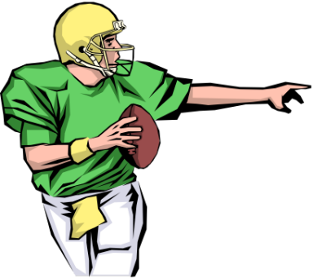
I love sports!

name



7th Grade Physical Education
Grade Sheet

1st Quarter 3rd Quarter
2nd Quarter 4th Quarter

Name__________________________________

Period_______ Oral Grade__________

1. Write at least one way you can improve your grade by the end of the quarter.

________________________________________________________________________________________________________________________________________________________________________________________________________

2. List your missing assignments

________________________________________________________________________________________________________________________________________________________________________________________________________

3. List any assessments or tests that you could re-take

________________________________________________________________________________________________________________________________________________________________________________________________________

__________________________________
Parent Signature

7th Grade Physical Education
Grade Sheet

1st Quarter 3rd Quarter
2nd Quarter 4th Quarter

Name___________________________________

Period_______ Quarter Grade__________

1. Write at least one way you can improve your grade for next quarter.

________________________________________________________________________________________________________________________________________________________________________________________________________

2. List your missing assignments

________________________________________________________________________________________________________________________________________________________________________________________________________

3. List any assessments or tests that you could re-take

________________________________________________________________________________________________________________________________________________________________________________________________________

__________________________________
Parent Signature

7th Grade Physical Education
Grade Sheet

1st Quarter 3rd Quarter
2nd Quarter 4th Quarter

Name__________________________________

Period_______ Oral Grade__________

1. Write at least one way you can improve your grade by the end of the quarter.

________________________________________________________________________________________________________________________________________________________________________________________________________

2. List your missing assignments

________________________________________________________________________________________________________________________________________________________________________________________________________

3. List any assessments or tests that you could re-take

________________________________________________________________________________________________________________________________________________________________________________________________________

__________________________________
Parent Signature

7th Grade Physical Education
Grade Sheet

1st Quarter 3rd Quarter
2nd Quarter 4th Quarter

Name___________________________________

Period_______ Quarter Grade__________

1. Write at least one way you can improve your grade for next quarter.

________________________________________________________________________________________________________________________________________________________________________________________________________

2. List your missing assignments

________________________________________________________________________________________________________________________________________________________________________________________________________

3. List any assessments or tests that you could re-take

________________________________________________________________________________________________________________________________________________________________________________________________________

__________________________________
Parent Signature

7th Grade Physical Education
Grade Sheet

1st Quarter 3rd Quarter
2nd Quarter 4th Quarter

Name__________________________________

Period_______ Oral Grade__________

1. Write at least one way you can improve your grade by the end of quarter.

________________________________________________________________________________________________________________________________________________________________________________________________________

2. List your missing assignments

________________________________________________________________________________________________________________________________________________________________________________________________________

3. List any assessments or tests that you could re-take

________________________________________________________________________________________________________________________________________________________________________________________________________

__________________________________
Parent Signature

7th Grade Physical Education
Grade Sheet

1st Quarter 3rd Quarter
2nd Quarter 4th Quarter

Name___________________________________

Period_______ Quarter Grade__________

1. Write at least one way you can improve your grade for next quarter.

________________________________________________________________________________________________________________________________________________________________________________________________________

2. List your missing assignments

________________________________________________________________________________________________________________________________________________________________________________________________________

3. List any assessments or tests that you could re-take

________________________________________________________________________________________________________________________________________________________________________________________________________

__________________________________
Parent Signature

7th Grade Physical Education
Grade Sheet

1st Quarter 3rd Quarter
2nd Quarter 4th Quarter

Name__________________________________

Period_______ Oral Grade__________

1. Write at least one way you can improve your grade by the end of the quarter.

________________________________________________________________________________________________________________________________________________________________________________________________________

2. List your missing assignments

________________________________________________________________________________________________________________________________________________________________________________________________________

3. List any assessments or tests that you could re-take

________________________________________________________________________________________________________________________________________________________________________________________________________

__________________________________
Parent Signature

7th Grade Physical Education
Grade Sheet

1st Quarter 3rd Quarter
2nd Quarter 4th Quarter

Name___________________________________

Period_______ Quarter Grade__________

1. Write at least one way you can improve your grade for next quarter.

________________________________________________________________________________________________________________________________________________________________________________________________________

2. List your missing assignments

________________________________________________________________________________________________________________________________________________________________________________________________________

3. List any assessments or tests that you could re-take

________________________________________________________________________________________________________________________________________________________________________________________________________

__________________________________
Parent Signature

SQUAD LINE SQUAD LINE

1st Quarter Names (Including yourself) 2nd Quarter Names (Including yourself)

Squad Line ____________ Squad Line ____________

1. Captain________________________ 1. Captain________________________

2. ______________________________ 2. ______________________________

3. ______________________________ 3. ______________________________

4. ______________________________ 4. ______________________________

5. _____________________________ 5. _____________________________

6. ______________________________ 6. ______________________________

7. ______________________________ 7. ______________________________

SQUAD LINE SQUAD LINE

3rd Quarter Names (Including yourself) 4th Quarter Names (Including yourself)

Squad Line ____________ Squad Line ____________

1. Captain_______________________ 1. Captain_______________________

2. ______________________________ 2. ______________________________

3. ______________________________ 3. ______________________________

4. ______________________________ 4. ______________________________

5. ______________________________ 5. ______________________________

6. ______________________________ 6. ______________________________

7. ______________________________ 7. ______________________________

What is Physical Fitness?

Physical fitness is made up of two components: Skill-related fitness and Health related fitness. Skill related fitness items are factors, which relate to the possibility of you becoming a good athlete. Are you fast? Do you have good eye hand coordination? Health related fitness components relate to how well the systems of your body operate. Are your heart and other muscles of your body in good shape?

SKILL RELATED FITNESS |  | HEALTH RELATED FITNESS
Agility |  | Flexibility
Power |  | Muscular Endurance
Reaction Time |  | Muscular Strength
Balance |  | Cardiovascular Fitness
Coordination |  | Body Composition
Speed



6 Components of Skill-Related Fitness

There are 6 skill-related components of physical fitness; agility, balance, power, reaction time, coordination and speed. These factors contribute toward your ability to successfully participate in sports activities. Regular participation in sports activities can have a very positive influence on your health and fitness. Individuals who have a higher level of skill related fitness are more likely to be physically active than those who have a lesser degree of skill.

Agility is the ability to change the position of your body quickly and to control the movement of your whole body. People with good agility are likely to excel in wrestling, gymnastics and soccer.

Balance is the ability to keep an upright posture while you are standing still or moving. People with good balance are likely to excel in gymnastics and surfing.

Coordination is the ability to use your senses, such as your eyes, together with your body parts, such as your arms, or to use two or more body parts at the same time. People with good hand-eye coordination or foot eye coordination excel in hitting and kicking games, such as baseball, tennis, soccer and golf.

Power is the ability to do strength performance quickly. It involves both strength and speed. People with power might have the ability to put the shot, throw the discus, play football and speed swim.

Reaction Time is the amount of time it takes you to get moving once you see the need to move. People with good reaction time will be able to make fast starts in track and swimming, or dodge a fast attack, as in fencing or karate.

Speed is the ability to perform a movement or cover a short distance in a short period of time. People with leg speed have the ability to run fast and people with arm speed can throw or hit a fastball.

If you are good at these skill related parts of fitness, you may be good at sports and games. Different sports require different parts of skill related fitness. Most sports require several of these parts. With practice, you can improve your skill in these areas. Some people have more natural ability in these areas than others. Regardless of your skill related abilities, there are many physical activities you can enjoy. Furthermore, good health does not come from being good in skill related fitness. Good health comes from doing activities designed to improve your health related fitness.

5 Components of Health Related Fitness

There are 5 health related components of physical fitness; flexibility, cardiovascular fitness, muscular strength, muscular endurance and body composition. Remember, FITNESS IS FOR EVERYONE. You do not have to be a good athlete to be physically fit. If you exercise regularly and follow basic training principles, you will improve your health related fitness. Maintaining acceptable levels of health related components of fitness are recognized as the key element of a healthy lifestyle. People who attain such levels of fitness reduce the risks of developing certain health problems, such as heart disease, low back pain and obesity, and improve their body’s ability to function. This is why health related fitness should be of utmost concern to everyone. As a result, in order to be considered a fit person, you must become adequate in all 5 components of fitness.

Flexibility is the ability to use your joints fully through a wide range of motion. Flexibility allows the freedom of movement and decreases muscle and joint injuries.

Cardiovascular Fitness is the ability to exercise your body for an extended period of time. It requires a strong heart, healthy lungs and clear blood vessels to supply the body with oxygen.

Muscular Strength is the amount of force your muscles can produce in one effort. People with good strength can perform daily tasks efficiently.

Muscular Endurance is the ability to use your muscles without tiring. You are better able to resist fatigue and more likely to have better posture and fewer back problems

Body Composition is the percentage of body weight that is fat compared to other tissues such as bone and muscle. Those in the proper range are more likely to avoid illness and have lower death rates. Extreme ranges are the most dangerous, too little body fat or too much body fat can cause serious health problems.

Review for Quiz

Agility is the ability to change direction of movement quickly while in control of your body.

Balance is the ability to maintain body equilibrium both stationary and in different movements.

Coordination is the ability to use your senses together with your body parts to perform smoothly and accurately.

Power is the measurement of how quickly a single, maximum, explosive movement can be performed.

Reaction time is the amount of time it takes you to get moving once you see the need to move.

Speed measure how much time it takes you to move a certain distance.

Flexibility is the ability to use your joints fully.

Cardiovascular fitness is the ability to exercise the entire body for long periods of time.

Muscular strength is the amount of force your muscles can produce in one effort.

Muscular endurance is the ability to use the muscle many times without getting tired.

Body Composition is the percentage of body fat compared to bones and muscle.

Physical Fitness Activities

Health Related
Physical Fitness Activities
Aerobics
Biking
Curl Ups
Jump Roping
Kicking
Pull Ups
Push Ups
Rock Climbing
Running
Soccer
Stretching
Striking
Swimming
Throwing
Walking
Yoga
Skill Related
Physical Fitness Activities
Baseball
Canoeing
Football
Gymnastics
High Jumping
Karate
Kayaking
Power Lifting
Shot Put
Skateboarding
Skiing
Snowboarding
Soccer
Tennis
Weight Lifting
Wrestling

Name ________________________ Per_________________

MATCHING QUIZ
Place the letter of the correct answer in the space provided.

1. | Cardiovascular Fitness | A. The range of movement possible at various joints
2. | Muscular Strength | B. Factors related to becoming physically fit
3. | Health related Fitness | C. Factors related to becoming a better “athlete”
4. | Skill Related Fitness | D. Relative percentage of muscle, fat, bone and other tissue
5. | Muscular Endurance | E. Ability to change the position of your body and control the movement of your body
6. | Flexibility | F. Ability to cover a distance in a short time
7. | Body Composition | G. The integration of hand and foot movement with your eyes
8. | Agility | H. The amount of time it takes you to get moving
9. | Power | I. The ability to use the muscle many times without getting tired.
10. | Reaction Time | J. The measurement of how quickly a single, maximum, explosive movement can be performed.
11. | Coordination | K. The amount of force your muscles can produce in one effort.
12. | Speed | L. The ability to exercise the entire body for long periods of time.

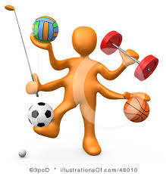
Name___________________________________________
Date____________________________
Period____________

Skill Components of Fitness
-Activity Log-

Component Activity Score

SPEED 40 Yard Dash Sec. ________________

REACTION TIME Ruler Drop & Catch # Inch. ________________

POWER Standing Long Jump Ft & In ________________

AGILITY 30 Foot Shuttle Run Sec. ________________

BALANCE 1 Leg Stand (Stork Test) Sec. Left ________________

Sec. Right ________________

COORDINATION Hand & Foot Juggling # of Hand ________________

# of Foot ________________

1. Which skill-component would you like to improve the most? Why?
________________________________________________________________________________________________________
________________________________________________________________________________________________________
________________________________________________________________________________________________________
________________________________________________________________________________________________________

2. Do you believe that the average person can improve their skill-components by practicing them regularly? Explain your answer.
________________________________________________________________________________________________________
________________________________________________________________________________________________________
________________________________________________________________________________________________________
________________________________________________________________________________________________________
3. How can practicing your skill-components help you in your daily activities (not sports)? Provide an example.

________________________________________________________________________________________________________
________________________________________________________________________________________________________
________________________________________________________________________________________________________
________________________________________________________________________________________________________

PRINCIPLES OF TRAINING

A GUIDE TO DEVELOPING A PROPER TRAINING PROGRAM
Exercise must be done correctly if it is to be good for you. A good, sound exercise program is built on 3 basic principles:

Overload – Progression – Specificity

Principle of Overload
The only way you can improve fitness through training is to do more than you normally do. You can do this by gradually increasing the amount of exercise.

Principle of Progression
For exercise to be a benefit, you need to start slowly and gradually increase the amount exercise you do over a period of time. For example, you might do an exercise 3 times one week, 4 the next and 5 times the following week until you are doing the exercise regularly. As you improve, you will notice the benefits of each gradual increase.

Principle of Specification
You must perform specific kinds of exercise to build specific parts of physical fitness. An exercise for strength will not necessarily improve flexibility or agility.

A Threshold of Training and Fitness Target Zone
The minimum amount of exercise necessary to build physical fitness is called the threshold of training. You must exercise at least at this level to build fitness. For best results, you should exercise above the in the Fitness Target Zone. Exercising in this zone means you are exercising just the right amount to build physical fitness. Fitness Target Zones are made up of 3 parts:

Frequency – Intensity - Time
Frequency deals with how often you have to work to improve physical fitness. For exercise to be of benefit you need to exercise 3-5 times a week.

Intensity deals with how hard you have to work to improve fitness. Too little or too easy exercise will not improve your fitness and may decrease it.

Time deals with how long you have to work to improve physical fitness. Current research states exercise should be done for 60 minutes at one time for maximum benefit.

Notes on Fitness Concepts

Notes on Principles of Training

Name ________________________________
Per ___________

CHECK YOUR KNOWLEDGE
Place the letter of the correct answer in the space provided.

1. | Fitness Target Zone | A. Exercising for one part of fitness
2. | Threshold of Training | B. How long you exercise
3. | Overload | C. More than normal exercising
4. | Specification | D. How hard you exercise
5. | Intensity | E. Minimum amount of exercise to improve physical fitness
6. | Frequency | F. Start slowly and increase amount of exercise
7. | Time | G. How often you exercise
8. | Progression | H. Best amount of exercise to improve physical fitness

CARDIOVASCULAR FITNESS VIDEO WORKSHEET

Name __________________________________

Period ______________

1. Write the definition of CARDIOVASCULAR FITNESS.
The ability of the ________________, ____________________, ___________________ and blood vessels to pump blood to the various systems of the body.
2 .The benefits of a strong cardiovascular system include;
- __________________________________________
- __________________________________________
- __________________________________________
- __________________________________________
- Decreased risk of heart disease

3. What does it take to have cardiovascular fitness?
- __________________________________________
- __________________________________________
- __________________________________________
- __________________________________________
- Fit Muscles

4. List a variety of tests to determine your cardiovascular fitness.
- V O2 max
- __________________________________________
- __________________________________________
- __________________________________________
- __________________________________________
- __________________________________________

5. Fill in the components of the FIT formula.
- F______________________________________
- I_______________________________________
- T_______________________________________

6. Complete the FIT formula for level 1 and level 2.
Level 1 FIT formula.
F=___________________________________________________ I=___________________________________________________
T=___________________________________________________

Level 2 FIT formula.
F=___________________________________________________ I=___________________________________________________
T=___________________________________________________

7. Fill out the PHYSICAL ACTIVITY PYRAMID

8. Name the two arteries used to take your pulse to determine your heart rate.
• neck or ___________________________________
• wrist or ___________________________________

9. Name the three basic components of a cardiovascular fitness program. Describe what is included in each component.
• Warm-up = ____________________________________
• _______________________________ = ____________________________________
• _______________________________ = slow walking and stretching

MUSCLE FITNESS VIDEO WORKSHEET

Name _________________________________________
Period _______________
1. What is Muscle Fitness?-

2. Define Muscular Strength. – ______________________________________________________________

3. Define Muscular Endurance. – ____________________________________________________________

4. How does muscular strength differ from muscular endurance?
a. Strength is the ability to lift _________________________.
b. Endurance is the ability to lift ______________________.
5. List the benefits of muscular fitness.
a. ________________________________________________________________________.
b.________________________________________________________________________.
c.________________________________________________________________________.
d.________________________________________________________________________.
e.________________________________________________________________________.

6. What are the dangers of steroid use?
a.________________________________________________________________________.
b.________________________________________________________________________.
c.________________________________________________________________________.
d.________________________________________________________________________.
e.________________________________________________________________________.
f.________________________________________________________________________.
g.________________________________________________________________________.

7. What is a “repetition”? _____________________________________________________.
8. What is a “set”? __________________________________________________________.
9. What is the common method of training called? _________________________________.

10. What are the 3 basic principles of muscular fitness?
a._Principle of __________________.
b. Principle of Progression
c._Principle of __________________.

11. What are the 3 components of the FIT formula? How much time should you spend in each exercise to build the 2 parts of muscle fitness?

FIT formula | Muscular Strength | Muscular Endurance
F
I
T

FLEXIBILITY VIDEO WORKSHEET

Name __________________________________________
Period _____________________

1. Define Flexibility-

2. Flexibility does the following; circle correct answers
- Aids in performance
- Prevents injury
- Maintains good posture
- Run the mile faster
3. Stretching is a method of ______________________________________________________
4. Flexibility is a type of ______________________________________________________

5. What are 3 reasons for doing stretching exercises?
a. __________________________________________________________
b. __________________________________________________________
c. __________________________________________________________

6. Name a few general body warm up stretches.

7. What stretching assessment is used for the Fitnessgram test? __________________________________

8. What are the 3 principles of fitness as they pertain to flexibility?
a. __________________________________________________________
b. __________________________________________________________
c. __________________________________________________________

8. According to the FIT formula for flexibility how often and long should you stretch?
Frequency- ____________________________________________________
Intensity- ________Stretch 10% of normal length_____________
Time- ______________________________________________________

9. Name 3 types of stretching exercises. Which one is the safest? ______________________________

a. __________________________________________________________
b. __________________________________________________________
c. __________________________________________________________
BODY COMPOSITION VIDEO WORKSHEET
Name___________________________________
Period____________________
1. Body Composition = ____________________, Muscle, _____________________, Body Fat

2. Body Fatness = percentage of ___________________ that is ____________________.

3. It is unhealthy to have too ___________________ or too ___________________ body fat.

4. Over-Fat = ______________________________ Under-Fat = ____________________________

5. Over Fat people can have:
- _________________________________
- _________________________________
- More surgery complications
6. Essential Body Fat = Amount of fat necessary __________________________________

7. Fat is necessary for:
- ______________________________
- ______________________________
- ______________________________
- ______Use of vitamins___________
8. Eating disorders:
- Anorexia Nervosa = __________extreme leanness_____________
- Anorexia Athletica = _________________________________________________
- Bulimia = __________binging & _______________________________________
9. Symptoms of Anorexia Nervosa = _____________________________, Surviving for extreme leanness, eating ______________________, and _______________________________.

10. Healthy body fat percentage:
- Girls _______________%
- Boys _______________%
11. Factors influencing Body Fatness: Heredity, ________________, ______________, & _____________

12. One pound of fat = _________________ calories.

13. In order to control fat, exercise should be _________________ times per week.

14. In order to control fat, eat _____________ meals per day, and eat _________________ snacks.

15. Safe fat loss = ____________________ pounds per week

16. How many calories do you need?
- Males = _________________________ Females = _________________________
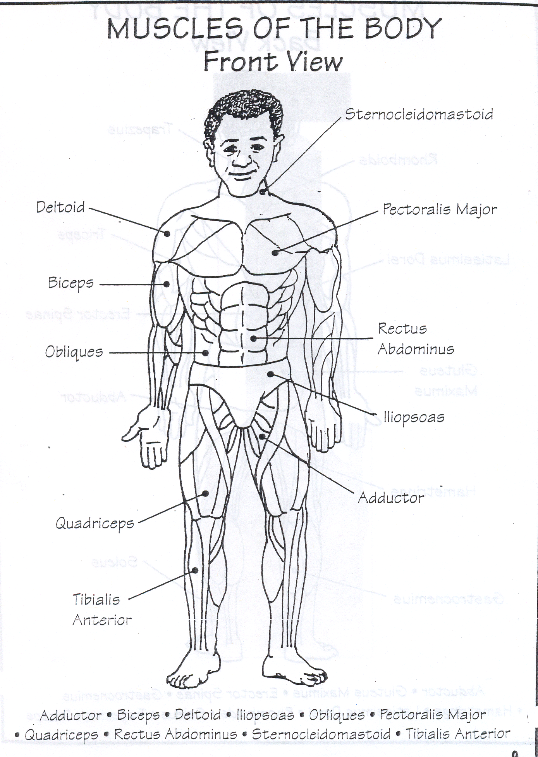
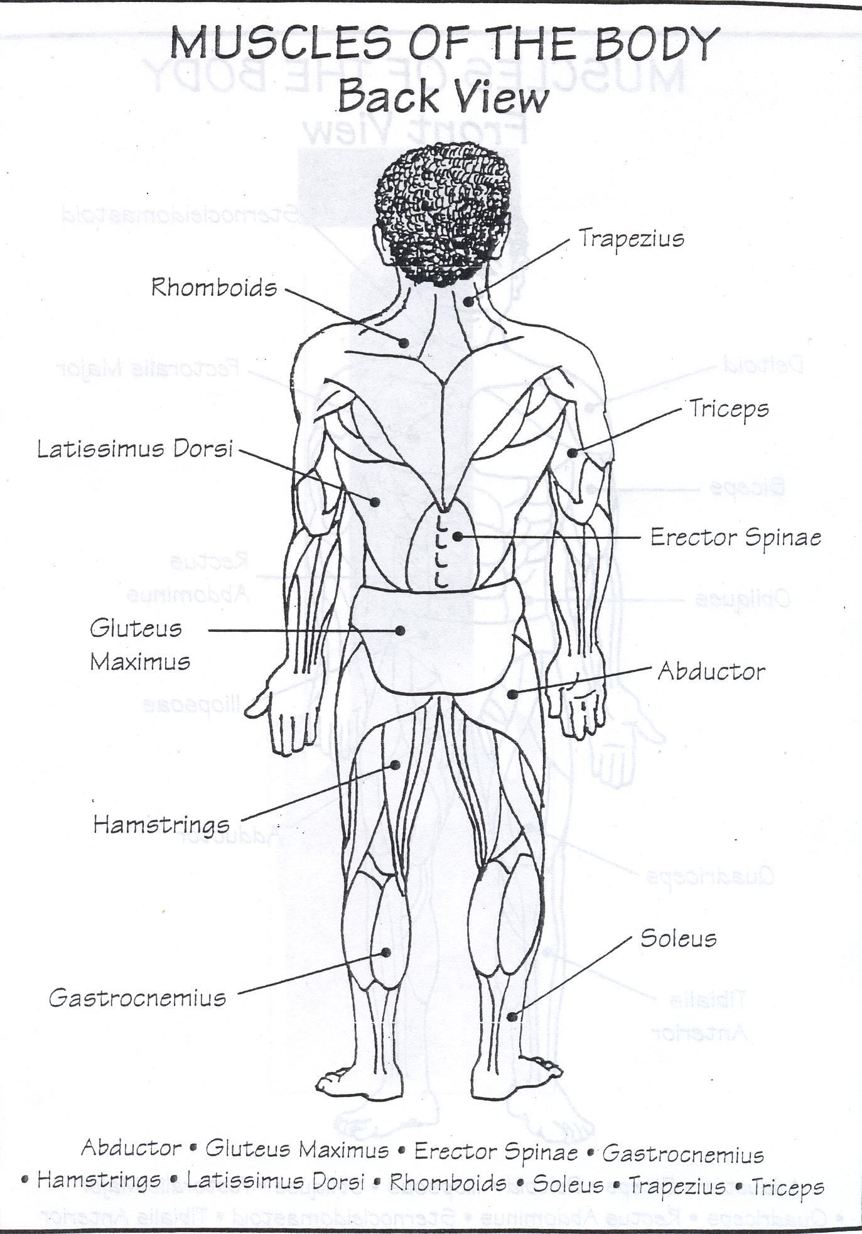

Fitness Notes

Name __________________________________________ Per __________

Muscle Matching Quiz
Place the letter of the correct answer in the space provided.

1. | The muscle located on the upper front half of the arm that curls the forearm and pops straight up when you flex. | A. Trapezius
2. | One of the upper back muscles that helps squeeze the shoulder blades together and begins with “R”. | B. Quadriceps
3. | The inner thigh muscle. | C. Biceps
4. | The muscle located on the upper back half of the arm that extends the forearm. | D. Sternocliedomastoid
5. | The muscles located on each side of the torso just below the shoulder blades and are referred to as climbers muscles. | E. Rectus Abdominus
6. | The muscle group located on the top half of the leg in the back. | F. Adductor
7. | The calf muscle located on the bottom half of the leg in the back. | G. Rhombiods
8. | The muscle group located on the top half of the leg in the front. | H. Obliques
9. | The calf muscle that extends the ankle joints and helps to point the toes. | I. Ilopsoas
10. | The shoulder muscles that raises the arm away from the side of the body. | J. Hamstrings
11. | The muscle that flexes the neck. | K. Deltoids
12. | The front hip muscle that flexes the hip. | L. Triceps
13. | The outer thigh muscle. | M. Soleus
14. | The back muscle that is an extension of the spine. | N. Abductor
15. | The stomach muscles. | O. Tibialis
16. | The buttocks muscle. | P. Erector Spinae
17. | The rib muscles. | Q. Latissimus Dorsi
18. | The shin muscle that flexes the ankle. | R. Gastrocnemius
19. | The muscle located in the upper chest. | S. Gluteus Maximus
20. | One of the upper back muscles that helps squeeze the shoulder blades together and begins with “T”. | T. Pectoralis Major

Name ______________________________
Score
/25

Date _______________ Period ______

#1FIND YOUR RESTING HEART RATE
When your fitness level improves, your resting heart rate may decrease as your heart becomes more efficient.
To measure your resting heart rate, follow these steps:

1. Before getting out of bed in the morning or after 15-20 minutes of rest and relaxation, FIND YOUR PULSE.

2. Use a wristwatch (or ask a parent to help) and count your pulse for ONE MINUTE.
220 | 220
_ (age) | _ (age)
= | =
_ (RHR) | _ (RHR)
= | =
X .60 (60%) | X .90 (90%)
= | =
+ (RHR) | + (RHR)
= | =
3. Record your RESTING HEART RATE (R.H.R) __________________

#2 FIND YOUR TARGET HEART RANGE
To improve your cardiovascular fitness it is important to exercise within your target heart range.(T.H.R.) The T.H.R. is determined when your heart rate is between 60% and 90% of the maximum heart rate. Follow the calculations below to find your T.H.R.

• Use a calculator.

• Ask your math teacher for help.

• Ask your parents for help.

• Check your work. 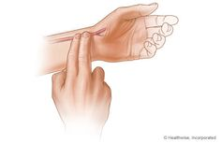

BONUS POINTS /25pts

FIND YOUR PARENT’S TARGET HEART RANGE
Remember, you must find their resting heart rate before you can complete the calculation.

EXERCISE W/ PARENT
220 | 220
_ (age) | _ (age)
= | =
_ (RHR) | _ (RHR)
= | =
X .60 (60%) | X .90 (90%)
= | =
+ (RHR) | + (RHR)
= | =

Participate in a cardiovascular activity, with your parent, for a minimum of 15 minutes. Your goal is to exercise in your target heart range for the full 15 minutes.

Perform a safe warm up before starting the cardiovascular activity

Examples of cardiovascular activities are biking, jogging, swimming,
cardio machine, aerobic dance, rowing, jumping rope or brisk walking.

Your heart must be beating in the target range to be successful.

Record your heart rate in the box.

YOU | 5 min. HR | 10 min HR | 15 min HR
PARENT | 5 min. HR | 10 min HR | 15 min HR

WRITING A SUMMARY
Now that you have completed the cardiovascular activity, complete the following:
Write a brief description of your experience. Include the; who, what, why and how did you feel.

Parent signature _________________________________________

Name _____________________________
Fitness and Nutrition

Date ______________________________

Period ____________
1. Name the 5 components of Health Related Fitness.

1. Body Composition

2.

3.

4.

5.

2. Name the 6 components of Skill Related Fitness.

1. Agility

2.

3.

4.

5.

6.

3. Name the 5 food groups with an example of a food from that category.

1. Grains, Breads & Cereals- whole wheat pancake

2.

3.

4.

5.

4. Describe the components of a healthy breakfast. (food groups or examples of food)

100 Ways Exercise Will Enrich
The Quality Of Your LIFE

1.Increase your self-confidence and self-esteem.
2. Improves your digestion.
3. Helps you sleep better.
4.Gives you more energy.
5.Adds a sparkle and radiance to your complexion.
6. Enhances your immune system.
7. Improves your body shape.
8. Burns up extra calories.
9. Tones and firms up muscles.
10. Provides more muscular definition.
11. Improves circulation and reduces blood pressure.
12. Lifts your spirits.
13. Reduces tension and reduces stress.
14. Enables you to lose weight and keep it off.
15. Makes you limber.
16. Builds strength.
17. Improves endurance.
18. Increases the lean muscle tissue in your body.
19. Improves your appetite for healthy foods.
20. Alleviates menstrual cramps.
21.Improves muscle chemistry.
22. Increase metabolic strength.
23. Improves coordination and balance.
24. Improves your posture.
25. Eases and can possibly eliminate back problems and pain.
26. Alters how your body uses calories more efficiently.
27. Lowers your resting heart rate.
28. Increases muscle size through an increase in muscle fibers.
29. Enables your body to utilize nutrients more efficiently.
30. Improves your body’s ability to burn fat.
31. Strengthens your bones.
32. Enhances oxygen transport through the body.
33. Improves liver function.
34. Strengthens your heart.
35. Improves blood flow throughout the body.
36. Helps to alleviate varicose veins.
37. Increase maximum cardiac output due to an increase in stroke volume.
38. Increase s the weight of the heart.
39. Increases the size of the heart.
40.Improves contractile function of the whole heart.
41. Deters heart disease.
42. Decreases cholesterol.
43. Decreases triglycerides.
44. Increases total hemoglobin.
45. Improves the body’s ability to remove lactic acids.
46. Improves the body’s ability to decrease heart rate after exercise.
47. Increases the number of open capillaries.
48. Increases blood flow to the active muscle at the peak of exercising.
49. Enhances the function of the cardiovascular system.
50. Enhances the function of the respiratory
system.
51. Improves the efficiency of breathing.
52. Increases lung capacity.
53. Improves bone metabolism.
54. Decreases the chances of osteoporosis.
55. Improves the development of the strength of connective tissue.
56. Increases strength of ligaments.
57. Enhances neuromuscular relaxation thus reduces anxiety and tension.
58. Enables you to relax more quickly and completely.
59. Alleviates depression.
60. Enhances clarity to the mind.
61. Improves emotional stability.
62. Makes you feel good.
63. Increases efficiently of your sweat glands.
64. Makes you better able to stay warm in cold environments.
65. Helps you to respond more efficiently to heat in that sweating begins at a lower body temperature.
66. Improves your body composition.
67. Decreases body density.
68. Decreases fat tissues more easily.

69.Helps you achieve a more agile body.

70. Increases posture, attitude about yourself and life.
71. Alleviated constipation.
72. Increases the efficiency of utilizing oxygen.
73. Enables you to meet new friends and develop fulfilling relationships.
74. Enables you to socialize while you are getting in shape.
75. Helps you to move past self-imposed limitations.
76. Gives you a great appreciation for life as a result of feeling better about yourself.
77. Enables you to enjoy all types of physical activities.
78. Make the clothes you wear look better on you.
79. Makes it easier to exercise consistently because you like how you look and feel and don’t want to lose it.

80. Gives you a greater desire to participate in life 100% and to take more risks as a result of increased confidence and self-esteem .
81. Improves athletic performance.

82. Improves the whole quality of your life.
83. May add a few years to your life.
84. Is the greatest tune up for your body.
85. Reduces joint discomfort.
86. Increases range of motion.
87. Gives you a feeling of control in your life and a belief that you can create any reality that you want.
88. Stimulates and improves concentration.
89. Brings color to your cheeks.
90. Decreases appetite when you work out 20 minutes to 1 hour before a meal.
91. Gets your mind off of irritations.
92. Stimulates a feeling of well being and accomplishment.
93. Invigorates the body and the mind.
94. It is a great way to enjoy the outdoors and nature.
95. Increases the body’s awareness if itself.
96. Reduces or precludes boredom.
97.Increases your ability to solve problems.
98. Gives you a clear prospective on ideas, issues, problems, and challenges.
99. Releases blockages and limitations in thinking.
100. Affords you the opportunity to experience your fullest potential.

SCORE /25 pts Name ___________________________

Date ________________ Per ________

Rincon Valley Middle School BINGO

Can jog a mile without stopping | Likes the  SF 49’s or the  SF Giants | Knows the names of 5 or more members of the class | Can do 25  curl ups | Likes to Dance
Uses sunscreen | Knows the 5 components of Health Related Fitness | Knows the 6 components of Skill Related Fitness | Wants to try out for a RVMS athletic team | Had a sister or brother that went to RVMS
Belongs to a Health Club or Gym | Knows how to take their Resting Heart Rate | Has a sports game on their computer | Reads the sports page or watches sports on TV | Eats breakfast every morning
Loves to be active | Made a 3 point basket | RVMS  FALCONS  RULE | Can do 5 push ups | Knows how to swim the freestyle
Is a good friend to have | Name 3 BEST behaviors | Participated in a 3k, 5k, 10k run | Knows what  F I T  Stands for | Can do 1 pull up
Exercises at least 3 times per week | Knows the mascot of RVMS | Has hit a home run | Has taken a martial arts class | Has played on a soccer team
Is a good TEAM player | Has scored a goal | Works out with a family member | Can touch your toes without bending the knees | Likes to help others succeed

Fun Activities in Physical Education

L T Y B M U E Z S S M O T S J
L U A E A S M C I H I A P I U
A M M B K S T C N K S R F N M
B B A N L C K R N A I U S N P
O L H I K E O E E N R P P E I
G I E Z C P O H T N U U D T C
N N F N E G Q S Y B G P D C K
O G A G E L I M E D A T W N L
M D M U S C U L A R R L H U E
S S E N T I F F L O O R L R B

R A L U C S A V O I D R A C A
B K U T F R X A V V T H A N L
X S E I H C N U R C K G F R L
F L E X I B I L I T Y O P B D
P J K I Q A O R D U I E K V Z

BASKETBALL
CARDIOVASCULAR
CRUNCHIES
DANCE
ENDURANCE
FLEXIBILITY
FLOOR HOCKEY
JUMP ROPE
MILE RUN
MONGOBALL
MUSCULAR
PICKLEBALL
PUSH UPS
SPRINTS
STRENGTH
TABLE TENNIS
TUMBLING
FITNESS
VOLLEYTENNIS

Created by Puzzlemaker at DiscoverySchool.com

Lifelong Fitness

D H E A P R O G R E S S I O N
L L O T T H R A C E M L A T S
O E D V F R L N I T F I N E P
H S S L E U A A S I T N T S E
S A L I C R F I T E O T I M C
E E S S U P L N N I L A Y P I
R W U D D Y E O T I P W G O F
H M N I O S I I A D N N F E I
T E T N S N S Q J D S G Z M C
C A R D I O V A S C U L A R I
B S K C P Y T I S N E T N I T
O B K M H X K G J V J M U T Y
D I O R B L Z R M G K Z Y Y K
Y C A T V C A G I L I T Y I Y
F R E Q U E N C Y D S B Q V P

BODY
CARDIOVASCULAR
COMPOSITION
ENDURANCE
FITNESS
FREQUENCY
INTENSITY
MUSCULAR
OVERLOAD
PROGRESSION
TIME
TRAINING
SPECIFICITY
THRESHOLD
AGILITY

Hidden Message

__ __ __ __ __ __ __ __ __ __ __ __ __

__ __ __ __ __ __ __ __ __ __ __ __ __

__ __ __ __ __ __ __ __

Fitness Tests
and Graphs

Blue Certificate = passing 6/6 Fitnessgram tests
Red Certificate = passing 5/6 Fitnessgram tests
Fitness Shirt = RVMS Elite Fitness status
Boys Girls
Mile Run 7:00 7:15
Push Ups 35 25
Curl Ups 65 65
Trunk Lift 10 10
Sit & Reach 10 12

Name ______________________________________________ Period ________

Fall Due Date ___________________ Spring Due Date ___________________

FITNESSGRAM Fitness Test

Record your Fitnessgram fitness test scores. Set a realistic and attainable goal for the Spring. Use the Healthy Fitness Zone (HFZ) on the back to help make your spring goals. Copy the HFZ for your current age. Circle yes or no based on your results. Parent signature _______________________________________

Fall Test | Fall Score AGE _____ | Goal for Spring | Healthy Fitness Zone based on age.  Did you meet the HFZ?
Mile |  |  | Yes No
Curl Up |  |  | Yes No
Trunk Lift |  |  | Yes No
Push Ups |  |  | Yes No
Sit and Reach | L R |  | Yes No
Height/Weight  BMI |  |  | Yes No

Directions: Record your Fitnessgram fitness test scores. Copy the HFZ for your current age. Circle yes or no based on your results. Parent signature ________________________________________________

Spring Test | Spring Score AGE _________ | Did you meet the HFZ?
Mile |  | Yes No
Curl Up |  | Yes No
Trunk Lift |  | Yes No
Push Ups |  | Yes No
Sit and Reach | L R | Yes No
Height/Weight  BMI |  | Yes No
FITNESSGRAM Healthy Fitness Zones MALE

 | Mile Run | Body Mass Index | Curl Up | Trunk Lift | Push Up | Sit & Reach
10 | ≥ 40.2 | 19.7 – 14.5 | ≥ 12 | 9 - 12 | ≥ 7 | 8
11 | ≥ 40.2 | 20.5 – 14.9 | ≥ 15 | 9 - 12 | ≥ 8 | 8
12 | ≥ 40.3 | 21.3 – 15.3 | ≥18 | 9 - 12 | ≥ 10 | 8
13 | ≥ 41.1 | 22.2 – 15.8 | ≥21 | 9 - 12 | ≥ 12 | 8
14 | ≥ 42.5 | 23.0 – 16.4 | ≥24 | 9 - 12 | ≥ 14 | 8

FITNESSGRAM Healthy Fitness Zones FEMALE

 | Mile Run | Body Mass Index | Curl Up | Trunk Lift | Push Up | Sit & Reach
10 | ≥ 40.2 | 20.3 – 14.3 | ≥ 12 | 9 - 12 | ≥ 7 | 9
11 | ≥ 40.2 | 21.2 – 14.7 | ≥ 15 | 9 - 12 | ≥ 7 | 10
12 | ≥ 40.1 | 22.1 – 15.2 | ≥18 | 9 - 12 | ≥ 7 | 10
13 | ≥ 39.7 | 22.9 – 15.7 | ≥18 | 9 - 12 | ≥ 7 | 10
14 | ≥ 39.4 | 23.6- 16.2 | ≥18 | 9 - 12 | ≥ 7 | 10

Blue Certificate = passing 6/6 Fitnessgram tests
Red Certificate = passing 5/6 Fitnessgram tests

Updated October 2015
California Department of Education

Fall Fitness Response
Name___________________________

Date ______________ Period_______
Directions: Use complete sentences for all responses.
1. Read the ESSENTIAL QUESTION.
2. Write a CLAIM to answer the essential question.
3. Provide 3 pieces of EVIDENCE to support your claim. Explain how each supports your claim.
4. Write a conclusion by restating your CLAIM using different words.

ESSENTIAL QUESTION- Do you consider yourself to be a physically fit person?

CLAIM
A CLAIM is a statement that clearly introduces an idea or belief that is supported by evidence. The following are some examples of how to start your CLAIM. You may use adjectives such as non, mildly, moderately, or extremely to describe your fitness level.
• Example 1- According to the results of the Fitnessgram Health Related Fitness test, I am _________...
• Example 2 -I believe I am _____________ because of the results of the Fitnessgram Health Related Fitness test.

Claim

EVIDENCE WITH REASONING
EVIDENCE includes, facts, figures, details, quotations, or other sources of data that support. Explain your evidence and how it supports your CLAIM.

1.

2.

3.

CONCLUSION- Summarize your evidence. Restate your CLAIM using different words.

Spring Fitness Response

Name___________________________

Date ______________ Period_______

Directions: Use complete sentences for all responses.
1. Read the ESSENTIAL QUESTION.
2. Write a CLAIM to answer the essential question.
3. Provide 3 pieces of EVIDENCE to support your claim. Explain how each supports your claim. (reasoning)
4. Write a conclusion by restating your CLAIM using different words.

ESSENTIAL QUESTION- Do you consider yourself to be a physically fit person?

CLAIM
A CLAIM is a statement that clearly introduces an idea or belief that is supported by evidence.

Claim

EVIDENCE WITH REASONING
EVIDENCE includes, facts, figures, details, quotations, or other sources of data that support. Explain your evidence and how it supports your CLAIM. (reasoning)

1.

2.

3.

CONCLUSION- Summarize your evidence. Restate your CLAIM using different words.

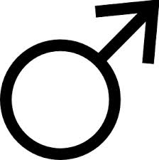
Name ________________________________
Period __________Date __________________

Fall Due Date ________________
Spring Due Date ______________

Measurement Chart for Boys

Measurement | Fall | Spring | Notes
Resting Heart Rate |  |  | Directions:
Height |  |  | -Lay tape on skin, do not squeeze tap
Weight |  |  | -Measure all muscles in a flexed position
Right Bicep |  |  | -Measure in inches
Left Bicep |  |  | -Measure to the closest ¼ inch
Chest |  |  | Measure partner, not yourself
Waist |  |  | Shoes are off during (height, weight, R & L foot)
Hips |  |  | Waist measurement:  Boy: Above belly button
Right Thigh |  |  | Girls: At natural curve
Left Thigh |  |  | Hip measurement at largest part of gluteus maximus
Right Calf

Left Calf

Right Foot

Left Foot

Fall Parent Signature ________________________
Spring Parent Signature_______________________
Name ________________________________

Period __________Date __________________

Fall Due Date ________________
Spring Due Date ______________

Measurement Chart for Girls

Measurement | Fall | Spring | Notes
Resting Heart Rate |  |  | Directions:
Height |  |  | -Lay tape on skin, do not squeeze tap
Weight |  |  | -Measure all muscles in a flexed position
Right Bicep |  |  | -Measure in inches
Left Bicep |  |  | -Measure to the closest ¼ inch
Bustline |  |  | Measure partner, not yourself
Waistline |  |  | Shoes are off during (height, weight, R & L foot)
Hips |  |  | Waist measurement:  Boy: Above belly button
Right Thigh |  |  | Girls: At natural curve
Left Thigh |  |  | Hip measurement at largest part of gluteus maximus
Right Calf

Left Calf

Right Foot

Left Foot

Fall Parent Signature ________________________
Spring Parent Signature_______________________

FITNESSGRAM Test Graphs

Directions for Graphing
1. Enter the date of the event in the box. Example 9/6.
2. Make a mark on the line directly above the box, which best represents your score.
3. Record your actual score on the line provided in the summary box.

FITNESSGRAM Cadence Curl Up
65
60
50
40
30
20
10
5
0
Date | / | / | / | / | / | / | /
Score

FITNESSGRAM Cadence Push Up
40
30
27
20
15
10
5
2
0
Date | / | / | / | / | / | / | /
Score

Run Graphs Name_____________________________ Period____________

  - Enter the date of the run, time, and heart rate in the boxes below the graph.
  - Make a mark on the line directly above the box that best represents your score.
  - Connect the marks with a line.
Mile Graph
12:00
11:30
11:00
10:45
10:30
10:15
10:00
9:45
9:30
9:15
9:00
8:45
8:30
8:15
8:00
7:45
7:30
7:15
7:00
6:45
6:30
6:15
6:00
5:45
Time
Heart Rate
Walk?
Date

½ Mile Graph
7:00
6:45
6:30
6:15
6:00
5:45
5:30
5:15
5:00
4:45
4:30
4:15
4:00
3:45
3:30
3:15
3:00
2:45
Time
Heart Rate
Walk?
Date

PACER GRAPH
90
85
80
75
70
65
60
55
50
45
40
35
30
25
20
15
10
5
Score
Heart Rate
Walk?
Date

Run Rubrics

STANDARD | Woodbury | ½ Mile | 1 Mile | PACER
Advanced | A – 25pts | 3:30 - Faster | 7:30 - Faster | 52 - 94
Proficient | B – 21 pts | 3:31 – 4:15 | 7:31 – 8:59 | 33-51
Basic | C – 18 pts | 4:16 – 5:30 | 9:00 – 10:59 | 16 - 32
Below Basic | F – 15 pts | 5:31 – Slower | 11:00 – Slower | 1-15
Walked | F- 12 pts | Walked | Walked | Walked
Missing Assignment | 0 pts | ½ Mile Make Up | 1 Mile Make Up | 1 Mile Make Up

Target Heart Rate Zone

Maximum HR 220 - ___________(Age) = ___________

Target Heart Rate Zone (65 – 85% of Max HR) = _______________ --- _______________

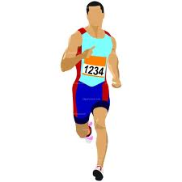
Name________________________________________
Period__________________
Run Graph
Standard
Advanced
Proficient
Basic
Below Basic
Far Below Basic
Act. # 1 2 3 4 5 6 7 8 9 10

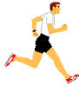
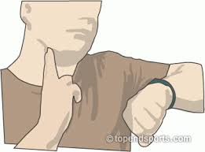

Act.  # | Date | Description of Activity  (Mile, PACER, Cooper Test, Etc.) | Score  (Time, Distance, or #) | Standard  (advanced, proficient, basic…) | Heart Rate
1
2
3
4
5
6
7
8
9
10

Run Log

Maximum HR 220 - ___________(Age) = ___________

Target Heart Rate Zone (65 – 85% of Max HR) = _______________ --- _______________

RUN DAY RUBRICS

 |  | ½ Mile | 1 Mile | PACER | Cooper Test | Mini Cooper Test | ABC Run | Partner Mile | Team PACER
Advanced | A+ | 3:30 - Faster | 7:30 - Faster | 52 - 94 | 2400 meters  (6 laps) | ≥ 1400 meters  (3.5 laps) | 6 Laps (< 15:00) | ≤ 14:00 | > 150
Proficient | A- | 3:31 – 4:15 | 7:31 – 8:59 | 33-51 | 2000 – 2300 meters (5 laps – 5.75 laps) | 1200 – 1300 meters  (3.0 – 3.25 laps) | 5 Laps (< 12:30) | 14:01 – 17:00 | 125 - 149
Basic | C- | 4:16 – 5:30 | 9:00 – 10:59 | 16 - 32 | 1700 – 1900 meters (4.25 – 4.75 laps) | 1000 meters  (2.5 laps) | 4 Laps (<10:00) | 17:01 – 20:00 | 100 - 124
Below Basic | D- | 5:31 – Slower | 11:00 – Slower | 1-15 | 1600 meters  (4 laps - less) | 900 meters  (2.25 laps - less) | 3 Laps (< 7:30) | 20:01 – Slower | 75 - 99
Far Below Basic | F ½ Credit | Walked | Walked | Walked | Walked | Walked | Walked | Walked | Walked

PACER SCORE SHEET Name ___________________________________________________ PER. _________

Make a slash / mark over each completed lap.

Make an X mark when the 1st fault occurs.

Circle the number when the 2nd fault occurs. This should be there final score.
1 | 1 | 2 | 3 | 4 | 5 | 6 | 7
2 | 8 | 9 | 10 | 11 | 12 | 13 | 14 | 15
3 | 16 | 17 | 18 | 19 | 20 | 21 | 22 | 23
4 | 24 | 25 | 26 | 27 | 28 | 29 | 30 | 31 | 32
5 | 33 | 34 | 35 | 36 | 37 | 38 | 39 | 40 | 41
6 | 42 | 43 | 44 | 45 | 46 | 47 | 48 | 49 | 50 | 51
7 | 52 | 53 | 54 | 55 | 56 | 57 | 58 | 59 | 60 | 61
8 | 62 | 63 | 64 | 65 | 66 | 67 | 68 | 69 | 70 | 71 | 72
9 | 73 | 74 | 75 | 76 | 77 | 78 | 79 | 80 | 81 | 82 | 83
10 | 84 | 85 | 86 | 87 | 88 | 89 | 90 | 91 | 92 | 93 | 94

Fall Fitness Test

Date________ _________ Score___________

Date________ _________ Score___________

Date________ _________ Score___________

PACER SCORE SHEET Name ___________________________________________________ PER. _________

Make a slash / mark over each completed lap.

Make an X mark when the 1st fault occurs.

Circle the number when the 2nd fault occurs. This should be there final score.

1 | 1 | 2 | 3 | 4 | 5 | 6 | 7
2 | 8 | 9 | 10 | 11 | 12 | 13 | 14 | 15
3 | 16 | 17 | 18 | 19 | 20 | 21 | 22 | 23
4 | 24 | 25 | 26 | 27 | 28 | 29 | 30 | 31 | 32
5 | 33 | 34 | 35 | 36 | 37 | 38 | 39 | 40 | 41
6 | 42 | 43 | 44 | 45 | 46 | 47 | 48 | 49 | 50 | 51
7 | 52 | 53 | 54 | 55 | 56 | 57 | 58 | 59 | 60 | 61
8 | 62 | 63 | 64 | 65 | 66 | 67 | 68 | 69 | 70 | 71 | 72
9 | 73 | 74 | 75 | 76 | 77 | 78 | 79 | 80 | 81 | 82 | 83
10 | 84 | 85 | 86 | 87 | 88 | 89 | 90 | 91 | 92 | 93 | 94

Spring Fitness Test

Date________ _________ Score___________

Date________ _________ Score___________

Date________ _________ Score___________

Partner Mile Activity
- Find a partner. Decide who will run today and who will run tomorrow.
- The runner will follow the warm up of the personal trainer and run the mile to the best of their ability. The goal is to run the mile without walking.
- The personal trainer will develop and perform a safe warm up for his/her partner. Start with a “cardio”* then move to specific stretches for the mile. The trainer will record each lap of the mile, encourage his/her partner throughout the mile, perform walking cool down with partner, review split times with partner and tell the teacher the final mile time.

*2 minutes non stop Cardio= your choice of a combination of the following warm ups; slow jog, jumping jacks, warm up routine, high knee skipping, grapevine, mountain climbers or your choice.

Fall Mile Fall Trainer Name _______________________________ Date __________

LAP | Fall Split Time | 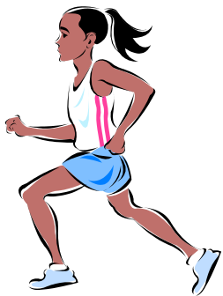  Comments on performance
1
2
3
4

Spring Mile Spring Trainer Name _______________________________ Date __________

LAP | Fall Split Time | Comments on performance
1
2
3
4

STANDARD | Woodbury | 1 Mile
Advanced | A – 25pts | 7:30 - Faster
Proficient | B – 21 pts | 7:31 – 8:59
Basic | C – 18 pts | 9:00 – 10:59
Below Basic | F – 15 pts | 11:00 – Slower
Walked | F- 12 pts | Walked
Missing Assignment | 0 pts | 1 Mile Make Up

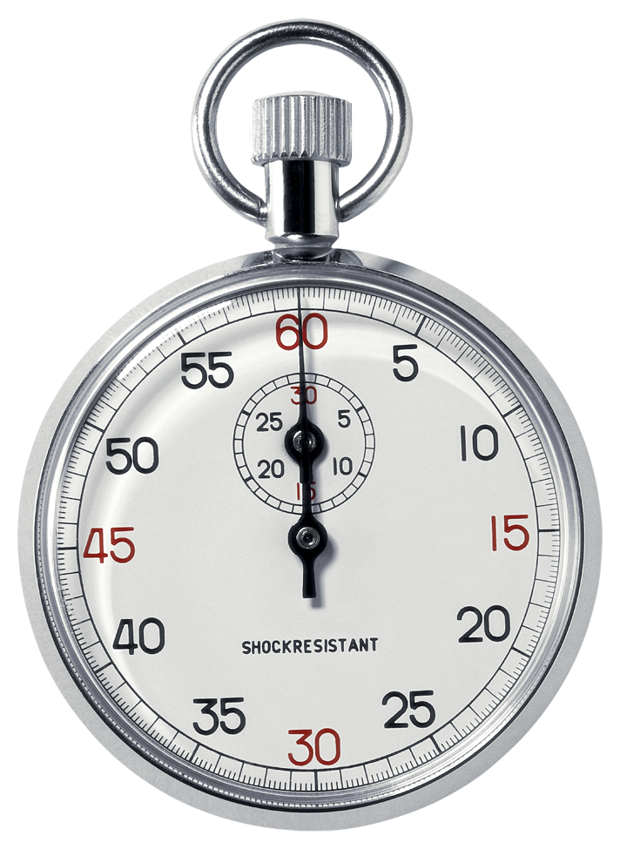
MILE MAKE-UP
Name_________________________________________
Period______________________
Date______________________

1. Complete a mile on a school track, with a parent.
2. Parent records split times (How much time has passed after each lap)
3. Parent signs this mile make-up sheet and student returns it to their physical education teacher.

LAP 1 _________________________________

LAP 2 _________________________________

LAP 3 _________________________________

LAP 4 _________________________________ MILE TIME __________________________

Circle the reason for the mile make-up. Medical Absence

Parent Signature _______________________________________________________________
------------------------------------------------------------------------------------------------------------
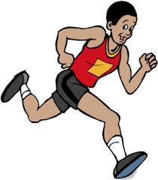
½ MILE MAKE-UP
Name_________________________________________
Period______________________
Date______________________

1. Complete a ½ mile on a school track, with a parent.
2. Parent records split times (How much time has passed after each lap)
3. Parent signs this ½ mile make-up sheet and student returns it to their physical education teacher.

LAP 1 _________________________________

LAP 2 _________________________________ ½ MILE TIME _______________________

Circle the reason for the mile make-up. Medical Absence

Parent Signature _______________________________________________________________

MILE MAKE-UP
Name_________________________________________
Period______________________
Date______________________

1. Complete a mile on a school track, with a parent.
2. Parent records split times (How much time has passed after each lap)
3. Parent signs this mile make-up sheet and student returns it to their physical education teacher.

LAP 1 _________________________________

LAP 2 _________________________________

LAP 3 _________________________________

LAP 4 _________________________________ MILE TIME __________________________

Circle the reason for the mile make-up. Medical Absence

Parent Signature _______________________________________________________________
------------------------------------------------------------------------------------------------------------
½ MILE MAKE-UP
Name_________________________________________
Period______________________
Date______________________

1. Complete a ½ mile on a school track, with a parent.
2. Parent records split times (How much time has passed after each lap)
3. Parent signs this ½ mile make-up sheet and student returns it to their physical education teacher.

LAP 1 _________________________________

LAP 2 _________________________________ ½ MILE TIME _______________________

Circle the reason for the mile make-up. Medical Absence

Parent Signature _______________________________________________________________

COOPER TEST MAKE-UP
Name_________________________________________
Period______________________
Date______________________
1. Complete the run you missed on a school track, with a parent.
2. Parent records time and distance below.
3. Parent signs this make-up sheet and student returns it to their physical education teacher.

- Circle which run you are completing:

Cooper Test (12 Minutes) or Mini-Cooper Test (6 Minutes)

- Record Exact Distance you ran in Meters (1 lap = 400meters) _____________________________
OR
- Record Exact Distance you ran in Laps (Ex: 6 ¾) _______________________________

- Circle the reason for the make-up. Medical Absence

- Parent Signature _______________________________________________________________

--------------------------------------------------------------------------------------------------------------------------

COOPER TEST MAKE-UP
Name_________________________________________
Period______________________
Date______________________
1. Complete the run you missed on a school track, with a parent.
2. Parent records time and distance below.
3. Parent signs this make-up sheet and student returns it to their physical education teacher.

- Circle which run you are completing:

Cooper Test (12 Minutes) or Mini-Cooper Test (6 Minutes)

- Record Exact Distance you ran in Meters (1 lap = 400meters) _____________________________
OR
- Record Exact Distance you ran in Laps (Ex: 6 ¾) _______________________________

- Circle the reason for the make-up. Medical Absence

- Parent Signature _______________________________________________________________

UPPER BODY

Plank
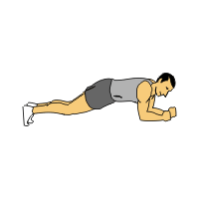
Side Plank
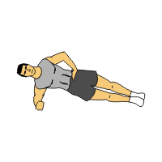
A. Push-Ups
B. Elevator Push-Ups
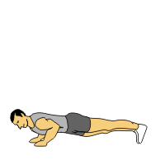

Tricep Dips

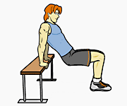

Burpees w/ Push Up
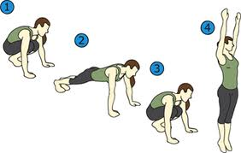

CORE

Bridge – Lower back

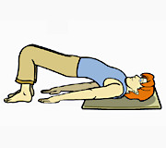

Bent Knee Crunches

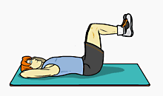

Bicycle Crunches
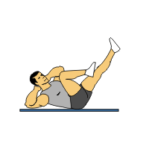
A. Flutter Kicks
B. Scissor Kicks
C. Leg Holds
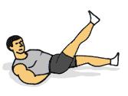

Curl Ups

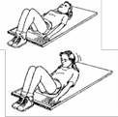

LOWER BODY
A. Stationary Lunges
B. Alternating Lunges
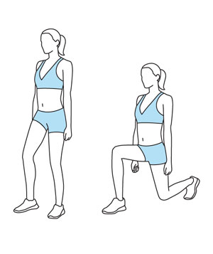
Squats
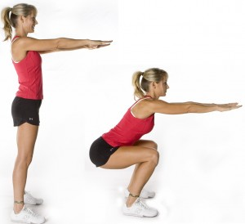

Wall Sit
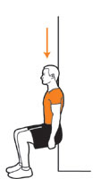

Wall Jumps
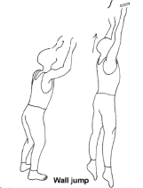

Mountain Climbers
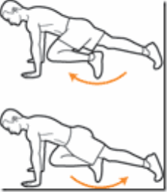

UPPER BODY

Plank-Push Ups
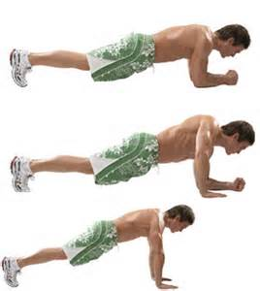

One Arm One Leg
High Plank
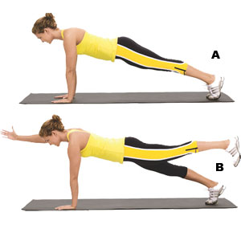
Birds – Upper Back
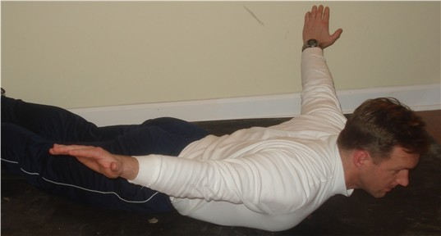

Inch Worms
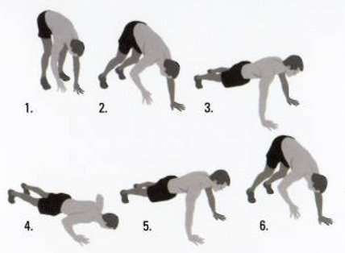

Push Up w/ knee twist

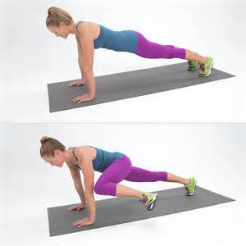

CORE

Superman (Lower Back)

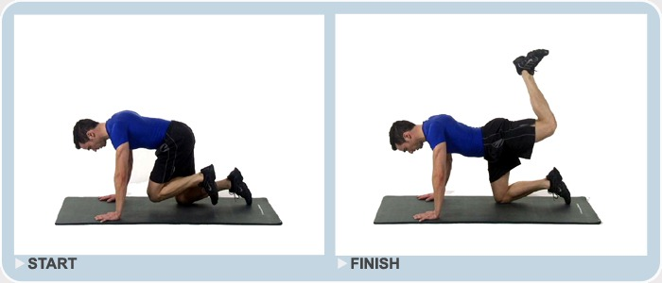
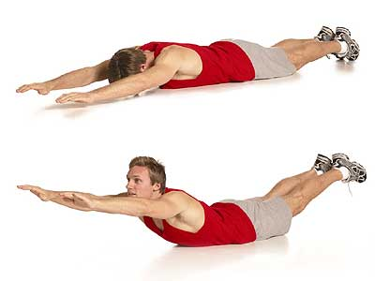

Russian Twist
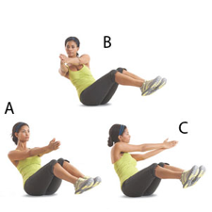

Lying Windmills
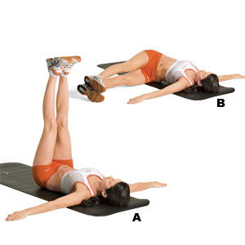

V-Ups
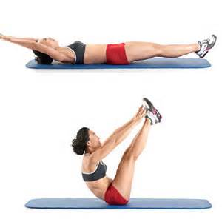

LOWER BODY

Donkey Kicks

Fire Hydrants
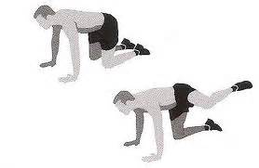

Single Leg Calf Raises
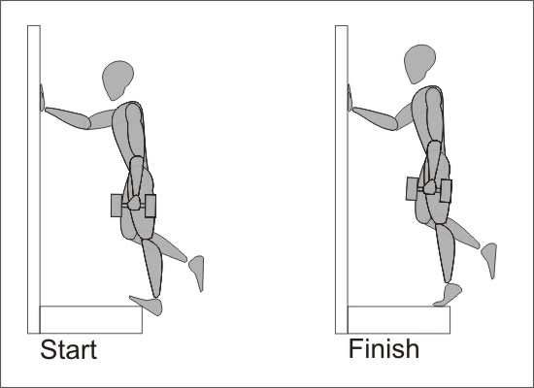

Lateral Leg Lifts
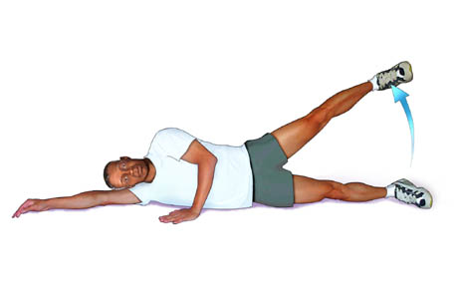
Tuck Jumps

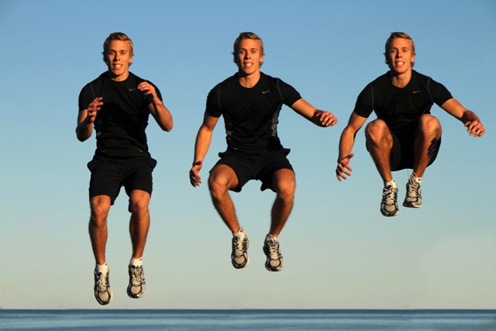

Neck Roll (Upper Trapezius)
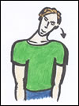

Deltoid Stretch
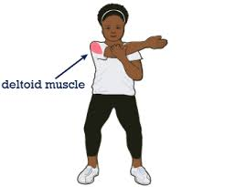

Pectoralis Stretch
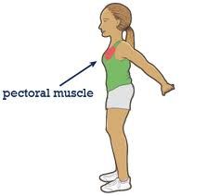

Tricep Stretch
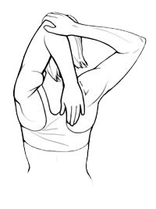

Shoulder Shrugs (Trapezius)

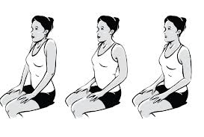

Upper/Middle Back Stretch
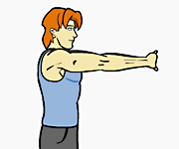

Side Stretch (Lats & Obliques)
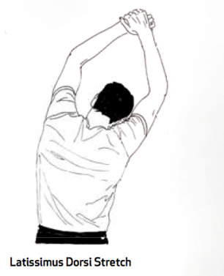

Bicep Stretch

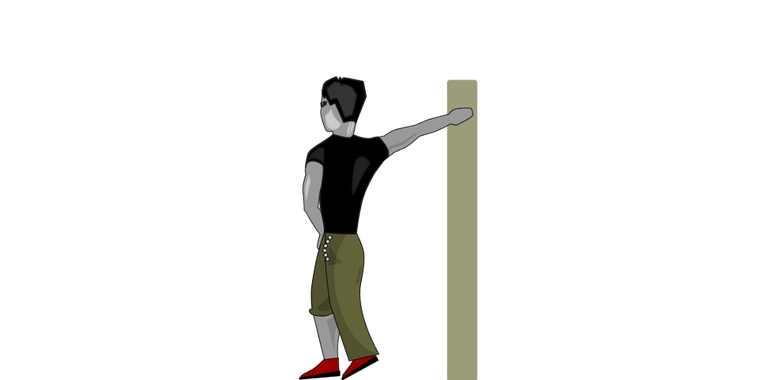

Arm Circles (Pecs & Deltoids)
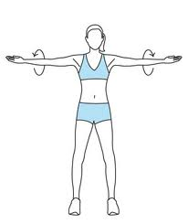

Lower Back Stretch (Erector Spinae)

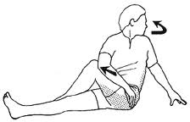
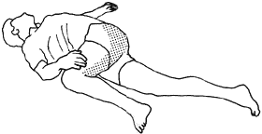

Abdominal Stretch

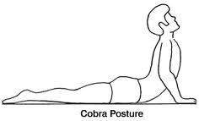

Forearm Stretch
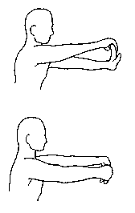

Glute Stretch
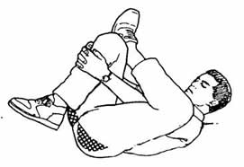

Adductor Stretch
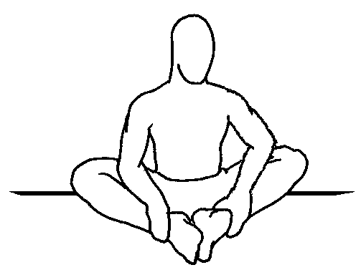

Abductor Stretch
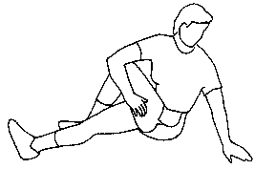

IT Band Stretch
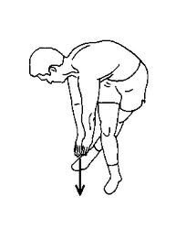

Quadricep Stretch
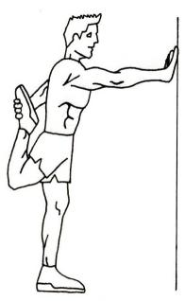
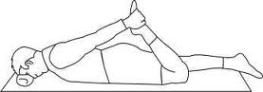

Gastrocnemius Stretch
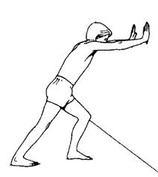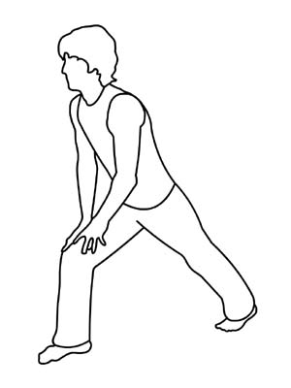

Soleus Stretch

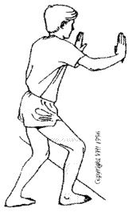

Hamstring Stretch
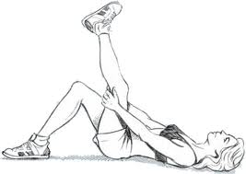
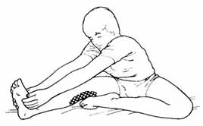
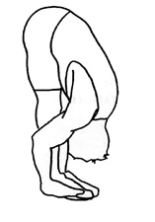

Hip Flexor Stretch

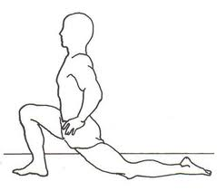

Name___________________
Count & record how many times or how long you can perform each exercise in 40/50 seconds.
You must use correct form!
Period _______

 | #1 | #2 | #3 | #4 | #5 | #6
1. Push-Ups
2. Squats
3. Alternating Lunges
4. Burpees
5. Calf Raises
6. Mountain Climbers
7. Full Curl-Ups
8. Shuttle Run
9. Wall Sit
(2:00 Maximum)
10. Plank
(5:00 Maximum)

