Fit Falcon Challenge
 | 1st Qtr | 2nd Qtr | 3rd Qtr | 4th Qtr | Extra
1. Push-Ups
2. Squats
3. Alternating Lunges
4. Burpees
5. Calf Raises
6. Mountain Climbers
7. Full Curl-Ups
8. Jump Rope
9. Shuttle Run
10. Wall Sit
(2:00 Maximum)
11. Plank
(5:00 Maximum)
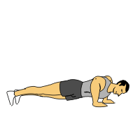
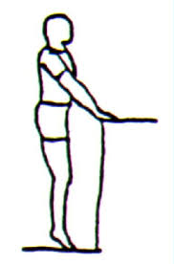
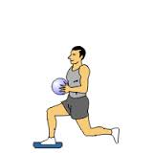
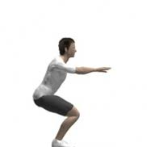
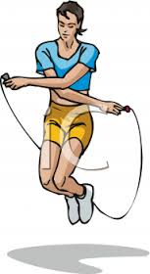
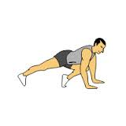
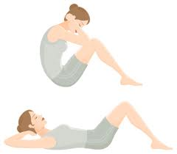
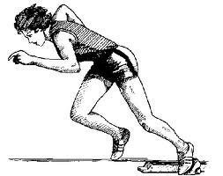
Count and record how many times or how long you can perform each exercise in 40/50 seconds. You must use correct form!

